**Year 13 Assessment Template – Designing a database-driven website – AS91891**

## Stage 1 – establishing exactly what your design requirements are

**Context:** It is a site designed so that users can view and listen to music uploaded by other users while also uploading their own.

**Purpose of the site:** The purpose would be to make a website for a community of up and coming Artists to share their music and be able to find listeners who can criticise and help each other grow. Like SoundCloud but a bit more personal.

**End-user requirements:**

The users should have an option to create an account and sign in, whilst logged into the website they should be able to upload their mp3 files to display under their name within the site.

Users will be able to find other users using the search bar in navbar. They can search song names or artist names.

Lastly, they will be able to play uploaded music with a built in mp3 player on the site rather than having to download it

(maybe) the users will be able to leave comments and feedback below the song.

**WEBSITE:**

**Implication**: Aesthetics and Minimalist design

**What it is** (in your own words):  Implementing Aesthetics and minimalist design means the site is pleasing to the eye and grabs the user’s attention while staying reasonable clear and each function is distinct.

**Why is it important to your project**: If the site is ugly and difficult to navigate people wouldn't want to take the time to get used to it, they'd move on pretty quick to a different alternative like Soundcloud.

**How will you address it**: I will make sure I use readable and well sized fonts and a fair bit of spacing between icons and buttons. Ill also find an aesthetically pleasing colour scheme and images/icons.

**Implication**: Functionality

**What it is** (in your own words): Making sure everything works as it should and works in a way that correlates with the purpose of the website. For example, the Navbar links must take you to the correct pages that they display to achieve functionality.

**Why is it important to your project**: Users should not have to jump through hoops to use the site it should be simple straight forward and functional

**How will you address it**: I will make sure all of the core pages are accessible in the navbar meaning if someone does get lost or somehow ends up on a dead page, they'll always have a way back. Of course, my links will need to be accurate and relevant to avoid confusion.

**DATABASE:**

**Implication**: Privacy

**What it is** (in your own words): Making sure people’s information is not viewable without consent.

**Why is it important to your project**: in any website with a login password should be hidden and encrypted to protect the user’s information within the database as if its leaked people won’t have to worry about hackers or scammers stealing it.

**How will you address it**: I'm planning on encrypting all passwords stored in the database and telling users what information will be public.

**Implication**: Sustainability and Future proofing

**What it is** (in your own words): Making sure the database can be easily updated by an admin and will keep up with new users and can support changes to the site with very few issues

**Why is it important to your project**: If the site were to grow, I would want to add features like commenting, direct messaging and an album release option to do this I need the database tables to be capable of being moved and changed. Also, if there is a large influx of users, I must be sure the website can handle that.

**How will you address it**: I am going to make sure all tables and labels have corrected naming and values?

**Research:** 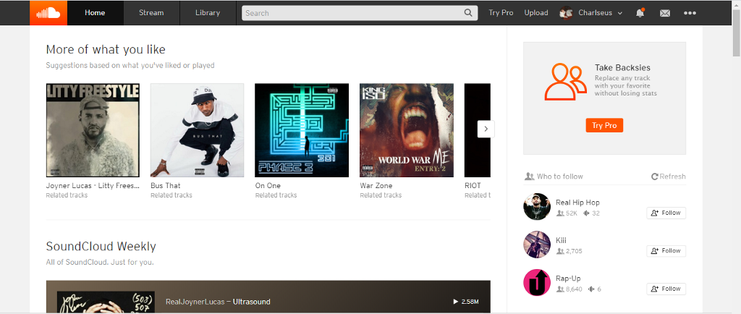

**Navbar:** The navbar is thin and stores a lot of content for my Site I would make it a bit thicker and have a few less icons and a lot of them aren't relevant to my site. I’ll come up with a Logo that gives the site recognition and add a search bar for finding users.

Centre: I like the jumbotron displaying recommendations and recent Releases also the side panel I could have a list of new users with links to their pages.

**Colour palette:**

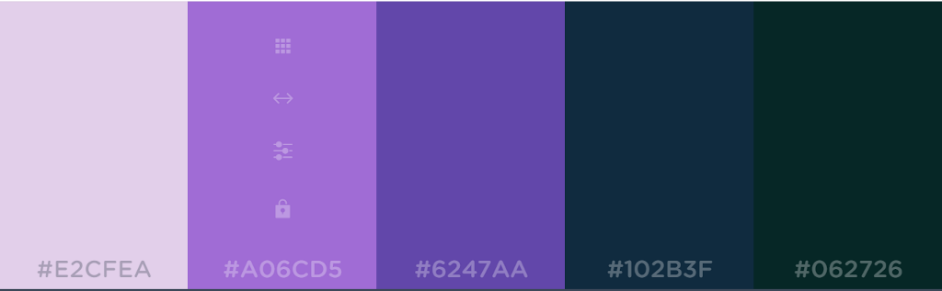

Neutral and aesthetically pleasing colour pallet.

**Fonts:** Font: I like the Roboto font but If I cannot Use it ill just use Arial.

C:\Users\CHARL\AppData\Local\Microsoft\Windows\INetCache\Content.MSO\D49A44C5.tmp

## Stage 2 - designs

**Initial designs**

**Design 1:** 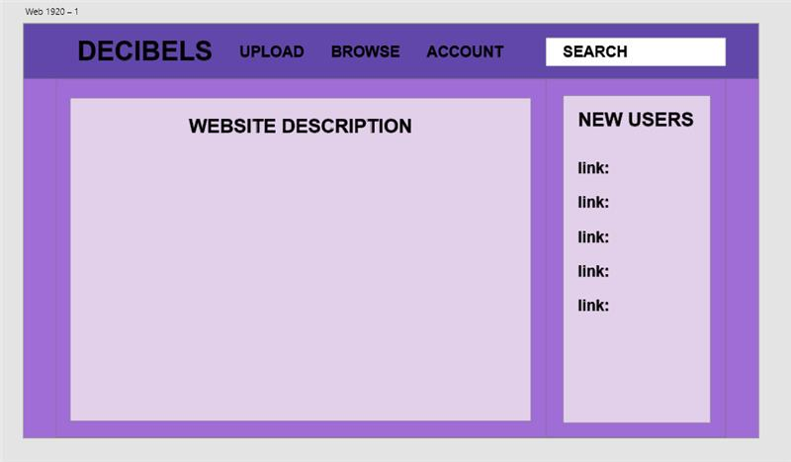

**Design 2:** 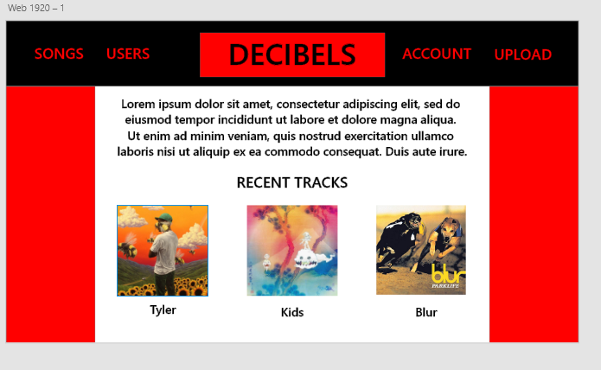

**Feedback on design 1**

**Student name:** James Ecroyd

**Feedback:**

I think you should keep body text areas white, and also put some content on the design to give us some context of how it will actually look once its finished, maybe even show a few examples of the web music player?

**Student name: Tyler Clink**

**Feedback:** Add some pictures maybe an image for the logo or in the web description box.

**Feedback on design 2**

**Student name: Andrei**

**Feedback: navbar red is good but the sides should be a less aggressive colour**

**Student name: James**

**Feedback:** i think you should choose a less saturated red, maybe use a unique font too. i think you should also group the items together to give the page some more structure

Sean and Sathya: add response to nav buttons

**Updated designs**

**Design 1:**

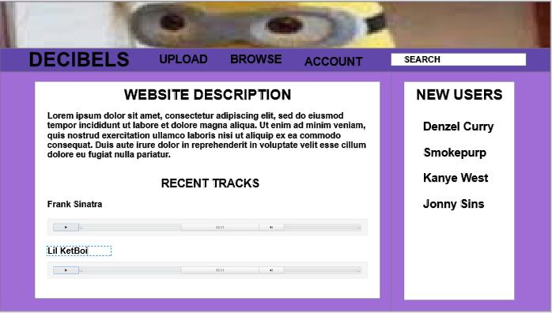

**Design 2:**

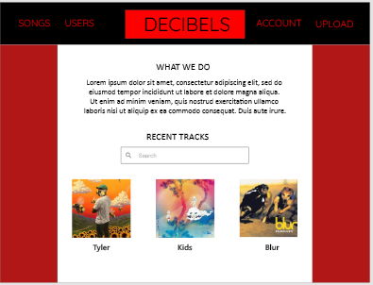

**Feedback on updated design 1**

**Student name:** James Ecroyd

**Feedback:** I'd pick a more unique font for headings etc, also I would give the items on the page more definition (borders, boxes etc)

**Student name:**

**Feedback:**

**Feedback on updated design 2**

**Student name: Hugo**

**Feedback: too simplistic, use more detail, a banner, an image for the logo more content.**

**Student name: Elizabeth Ashton**

**Feedback: why is there a search bar in the recent track’s thing, probably put it somewhere else**

**Proposed final design:**

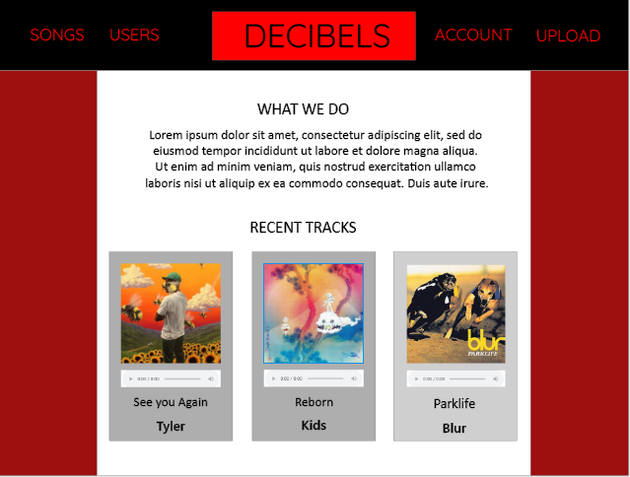

**Feedback on proposed final design**

**Student name: Sean**

**Feedback: I prefer the darker Gray for the cards also its quite simple in design and may need a bit more on screen.**

**Student name: tyler**

**Feedback: it ok idk man**

## Stage 3 – Final design decision and justification

**Updated final design**

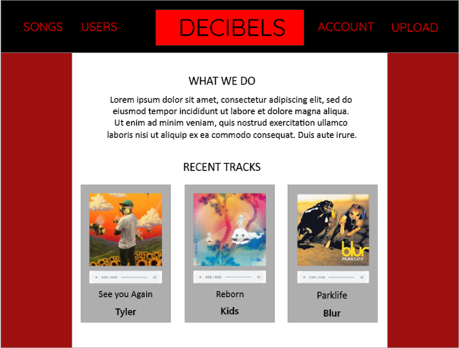

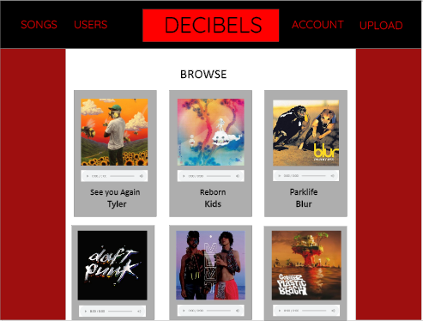

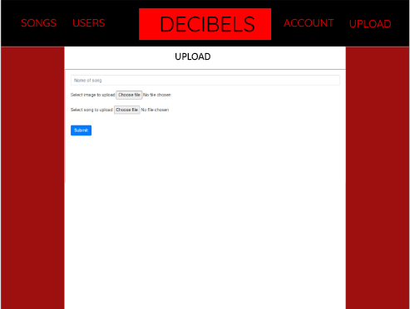

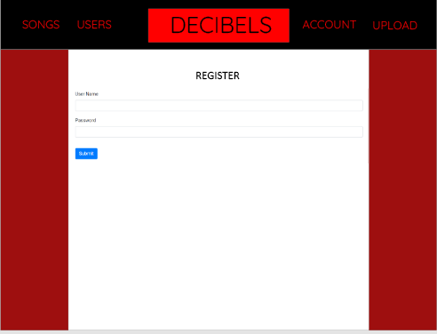

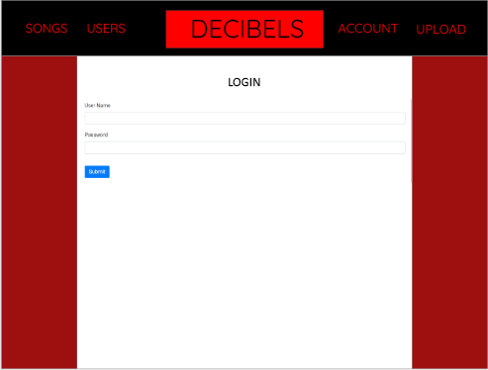

**Evaluation of the final design**

Design conventions:

My design starts with the navbar that draws the user’s attention to the large DECIBELS title which takes them to the home page. The other nav buttons are also big and are coloured a contrasting red so that people know they are there and notice them.

On the home page it is up to the Users to get each other’s attention with the album covers they choose for their tracks, the most recent tracks are displayed on the home and browse page and are visible to anyone visiting the site they take up most of the page to ensure they get the users attention and are displayed in a grey card contrasting the white background. This website isn’t about getting attention for its own properties its more for helping artists get more attention on their music.

**Relevant implications:**

For Aesthetics and Minimalist Design, I decided to keep my sites design very simple and basic meaning there is not much to take the users attention away from the music while still being easy to navigate and find the available features. Its hard to get lost with the consistent navbar and large contrasting buttons to navigate the site.

I checked that every aspect of the design functions properly. I also used headers to redirect users to appropriate pages after completing forms or if they try to use functions that are inappropriate for their login status for example someone who is not logged in will be redirected to home when trying to upload and people logged in cant login without first logging out. Its straightforward and functions as expected.

**End-user requirements:**

I didn’t end up implementing a search bar because I didn’t see it as being a vital part of the site with how small it is apart from that I met all end user requirements I set, they can register, login, upload music and browse which is everything I would want for a site like this.

If I were to add anything it would be a search bar, comments, likes and a way of seeing how many listens your songs have.

**Project Management**

**ADOBE XD**

**I used adobe XD to come up with all of my designs**

**Trello**

